Incident Response Handbook:
Project: Phishing → Ransomware Simulation (MailHog + GoPhish)
Author:
-Abdulrahman Al-Sayed Abdulaziz
-Khaled Mohamed Mohamed
-Kareem Ibrahim Mahmoud Omar
-Abdul Rahman Ali Abu Al-Maati
-Mohammed Ahmed Issa
-Mazen Mohamed Fathi

Table of Contents
- Project Overview
- Ethical & Legal Disclaimer
- Environment & System Requirements
- Installation & Configuration
  - MailHog
  - GoPhish
  - Python & PyInstaller (payload build)
- Phishing Campaign Setup (GoPhish)
  - Email template (HTML & plaintext)
  - Sending profile (MailHog)
  - Target group (CSV example)
- Payload Design (ticket.exe)
  - Behavior (mock ransomware)
  - Source code (example)
  - Building the executable
  - Hosting the payload
- Running the Simulation (step-by-step)
- Observing Results & Metrics
- Disk & Memory Image Acquisition
- Forensic Analysis & Indicators of Compromise (IOCs)
- MITRE ATT&CK Mapping
- Cyber Kill Chain
- Incident Response and Post-Incident Activities
- Recommendations & Mitigations
- Project Summary & Conclusion

1. Project Overview
Objective: This project demonstrates a controlled phishing campaign that delivers a benign, mock ransomware payload. The educational goals are:
- Show how phishing can deliver malicious payloads.
- Demonstrate how an unsuspecting user can be tricked into executing a payload.
- Gather campaign metrics (open, click rates) using GoPhish.
- Teach detection, mitigation, and incident response best practices.
Scope: Local/lab environment using MailHog as a local SMTP capture server and GoPhish as the phishing framework. The ticket.exe payload is a safe, non-destructive simulation that shows ransom-note behavior without encrypting real user data.

3. Environment & System Requirements
Minimum recommended: - CPU: 2 cores - RAM: 4 GB (2 GB may suffice for very small tests) - Disk: 10 GB free - OS: Windows 10/11, Ubuntu 20.04+, or macOS (latest) - Network: Localhost / isolated lab network
Software: - GoPhish (latest release) - MailHog (latest release) - Python 3.8+ and PyInstaller (for building the payload) - Browser for admin UIs (Chrome, Firefox)
Ports used (default): - MailHog SMTP: 1025 - MailHog HTTP UI: 8025 - GoPhish Admin: 3333 (HTTPS by default) - GoPhish Phishing server: 80 (HTTP) or custom port in config.json - Local payload hosting (example): 8000 (Python http.server)

4. Installation & Configuration
Note: All commands are examples. Adjust paths and permissions for your OS.

4.1 MailHog
Installation (Linux/macOS): - Option 1 (prebuilt binary): Download the appropriate binary from MailHog releases and place it in /usr/local/bin. - Option 2 (Homebrew macOS): brew update && brew install mailhog.
Run MailHog:
# start MailHog (default ports 1025 SMTP, 8025 HTTP)
mailhog
# or if using a binary
./MailHog
Verify: - Open http://localhost:8025 to view MailHog UI. - MailHog will receive emails sent to SMTP port 1025.
Configuration tips: - If port conflicts exist, stop the conflicting service or map MailHog to different ports. - Ensure local firewall allows loopback connections for the chosen ports.

4.2 GoPhish
Installation: - Download the latest GoPhish release from the official repository. - Unzip and place the folder in a suitable location (e.g., ~/gophish).
Run GoPhish:
cd ~/gophish
# On Linux/macOS
./gophish
# On Windows (PowerShell)
.\\gophish.exe
Default config: - admin_server.listen_url → 127.0.0.1:3333 - phish_server.listen_url → 0.0.0.0:80
Accessing UI: - Open a browser to https://127.0.0.1:3333 (Admin panel) and log in with the generated credentials. Change password on first login.
Important: If you cannot bind to port 80 for the phishing server, change phish_server.listen_url to 127.0.0.1:8080 and update templates/links accordingly.

4.3 Python & PyInstaller (payload build)
Install Python: - Ensure Python 3.8+ is installed and python/python3 is on PATH.
Install PyInstaller:
pip install pyinstaller
Create a virtualenv (optional but recommended):
python3 -m venv venv
source venv/bin/activate # Linux/macOS
venv\\Scripts\\activate # Windows

5. Phishing Campaign Setup (GoPhish)

5.1 Create Email Template
Example subject and body (HTML):
Subject: Congratulations! You’ve Won an iPhone 17 Pro
HTML body (example):
<!doctype html>
<html>
<body>
<div style="font-family: Arial, sans-serif;">
<img src="https://example.com/logo.png" alt="Fawryz Logo" style="width:160px;" />
<h2>Congratulations!</h2>
<p>Dear {{.FirstName}},</p>
<p>We are excited to inform you that you have been randomly selected to receive a brand new <strong>iPhone 17 Pro</strong> in our customer appreciation giveaway.</p>
<p>To claim your prize, please download your raffle ticket and run it on your Windows machine:</p>
<p><a href="http://localhost:8000/ticket.exe">Download your ticket</a></p>
<p>Best regards,<br/>Fawryz Team</p>
</div>
</body>
</html>
Template notes: - Replace {{.FirstName}} with GoPhish template variables where appropriate. - Use realistic logos and formatting to increase believability for training, but do not impersonate any real organization without permission. - Leave the default GoPhish tracking image enabled if you want open/click tracking.
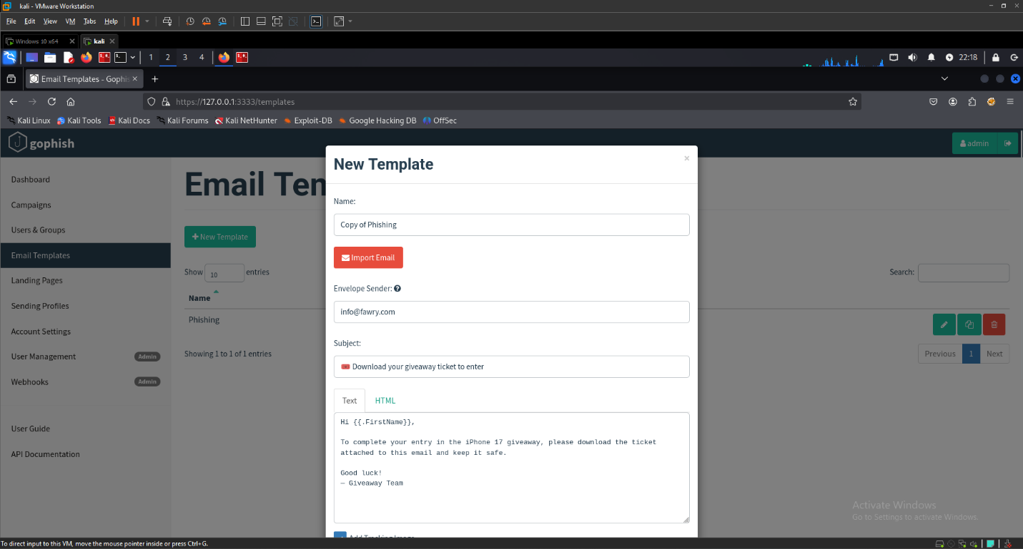

5.2 Sending Profile (MailHog)
In GoPhish Admin: - Navigate to Sending Profiles -> New Profile. - SMTP Host: localhost:1025 - From Address: support@fawryz.com (mailhog will accept it) - Save and Send a Test email to verify MailHog receives it.

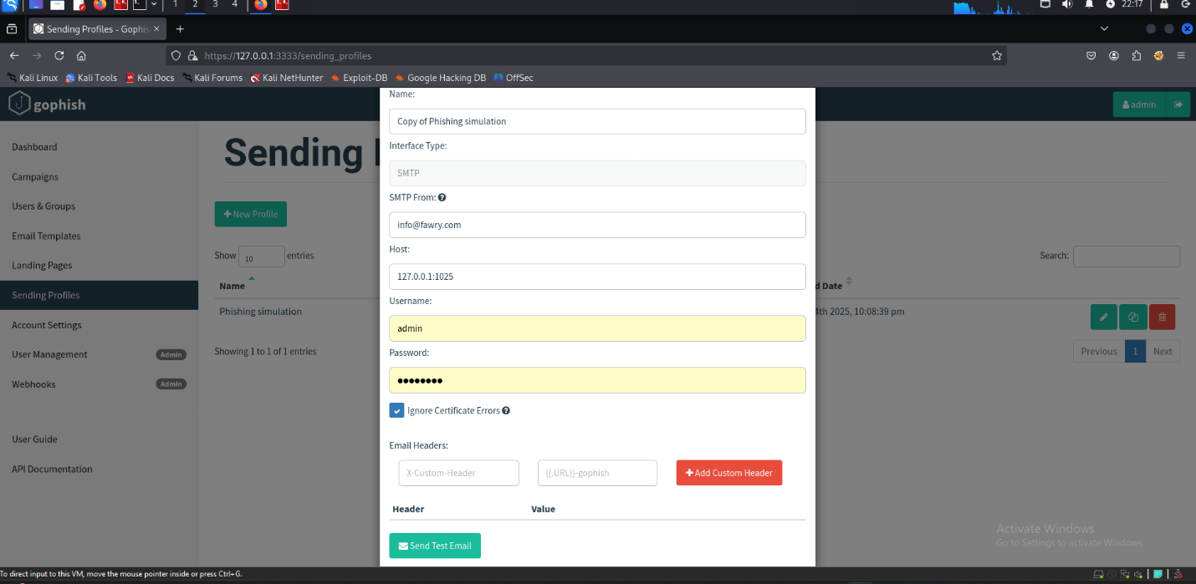

5.3 Target Groups (CSV import)
CSV example (headers are optional; GoPhish accepts name/email columns):
first_name,last_name,email
Marwan,Sherif,MarwanSherif@mail.com
Alice,Smith,alice.smith@example.test
- In GoPhish: Users & Groups -> New Group -> Import CSV (or add single users manually).
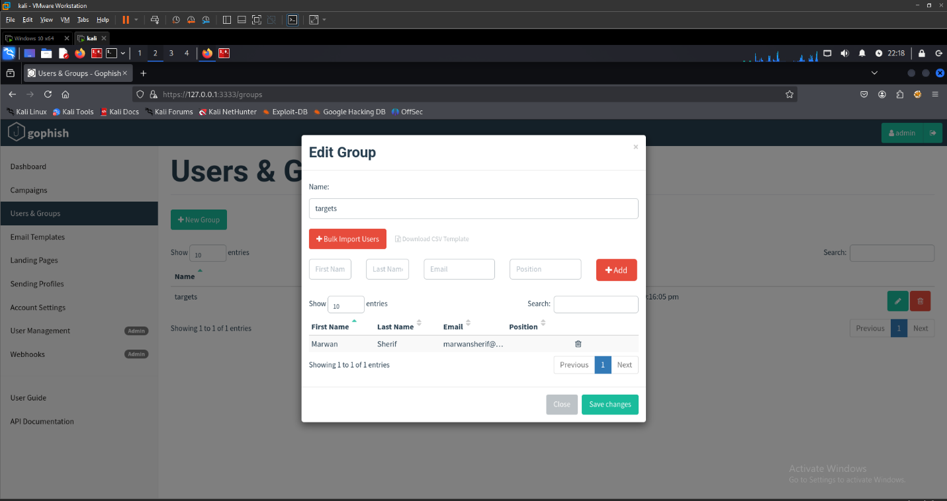

6. Payload Design (ticket.exe) — Safe handling and reporting note
Note: For background research we obtained a known WannaCry ransomware sample for analysis only. The sample was not executed on any production system. All handling of the sample was done in a controlled, isolated lab environment under supervisor approval. The live demonstration shown in this project used a benign mock payload (ticket.exe) that only simulates ransomware behavior (pop-up ransom message and safe file rename inside a contained demo folder) and does not encrypt or damage real user data.
- What we did with the WannaCry sample: referenced for academic analysis and comparison (static metadata and high-level behavior only). No execution, no distribution, and no replication of the malware code is included in this report.
- What we used in the demo: ticket.exe (a safe, reversible mock payload) to show the user-facing effects without risk.
- Safety measures (summary):
  - Analysis work limited to an isolated VM in an air-gapped/test lab.
  - Supervisor / lab authorization was obtained.
  - No real user files or production networks were used.
  - All artifacts and screenshots included in the report are sanitized.

7. Running the Simulation (Step-by-step)
- Start MailHog: mailhog (ensure SMTP 1025 and UI 8025 are active).
- Start GoPhish: ./gophish (note admin URL and phishing server URL). Log into admin console.
- Build ticket.exe and start a local HTTP server to host it: python3 -m http.server 8000 in the directory containing ticket.exe.
- In GoPhish, create the email template that links to http://localhost:8000/ticket.exe.
- Create a sending profile pointing to localhost:1025 (MailHog).
- Prepare a target group with one or more test email addresses.
- Launch the campaign from GoPhish and monitor the campaign dashboard.
- Open MailHog at http://localhost:8025 to view delivered emails. Click the link to download & run ticket.exe (or instruct a test user to do so in a VM).
- Observe the payload behaviour (ransom note popup and demo file renaming) and check logs generated by the payload.
- Review GoPhish campaign results for opens/clicks.

8. Observing Results & Metrics
GoPhish Dashboard Metrics: - Sent: Number of emails sent. - Delivered: MailHog reception (GoPhish shows send status). - Opened: Tracked via embedded tracking pixel. - Clicked: Tracked via link redirection through GoPhish.
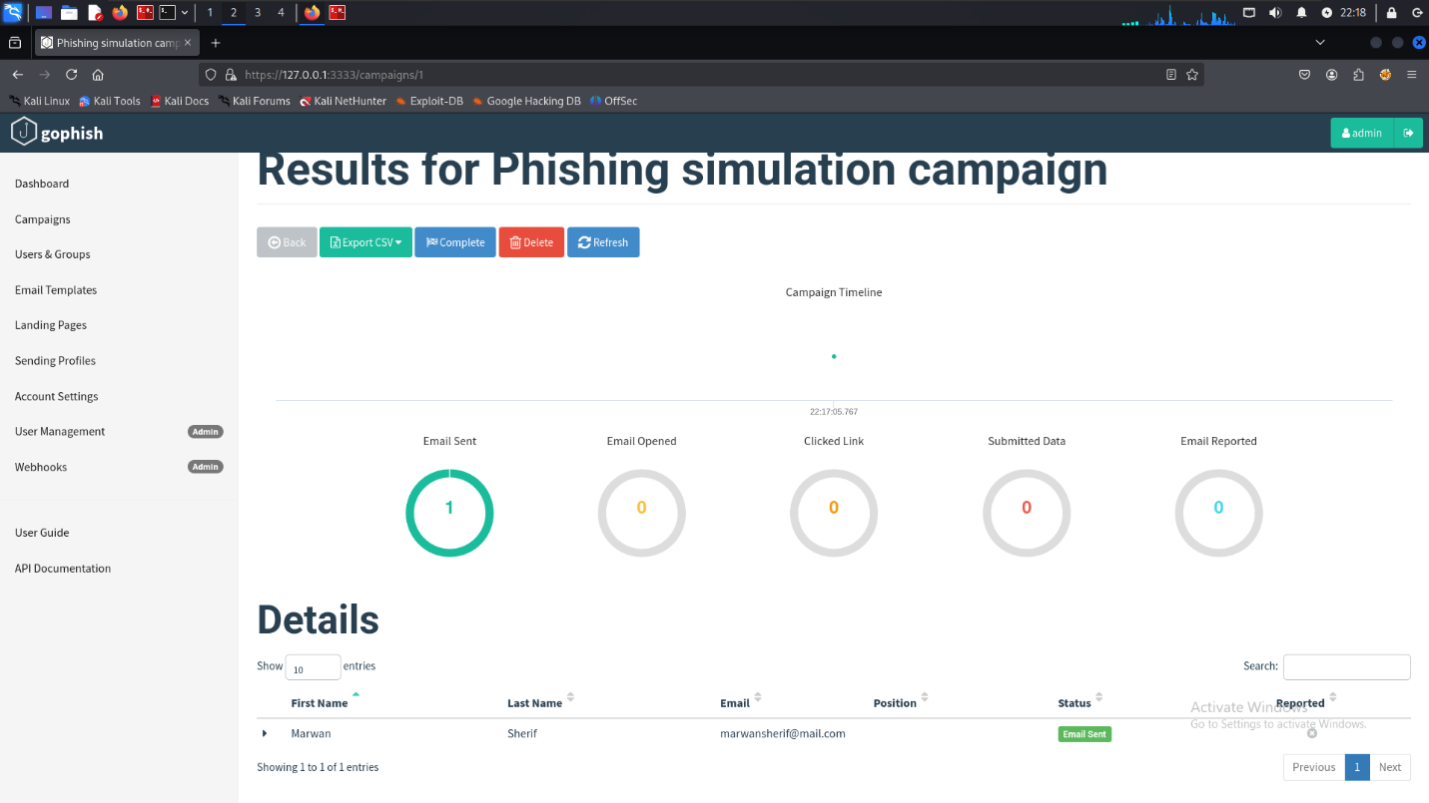

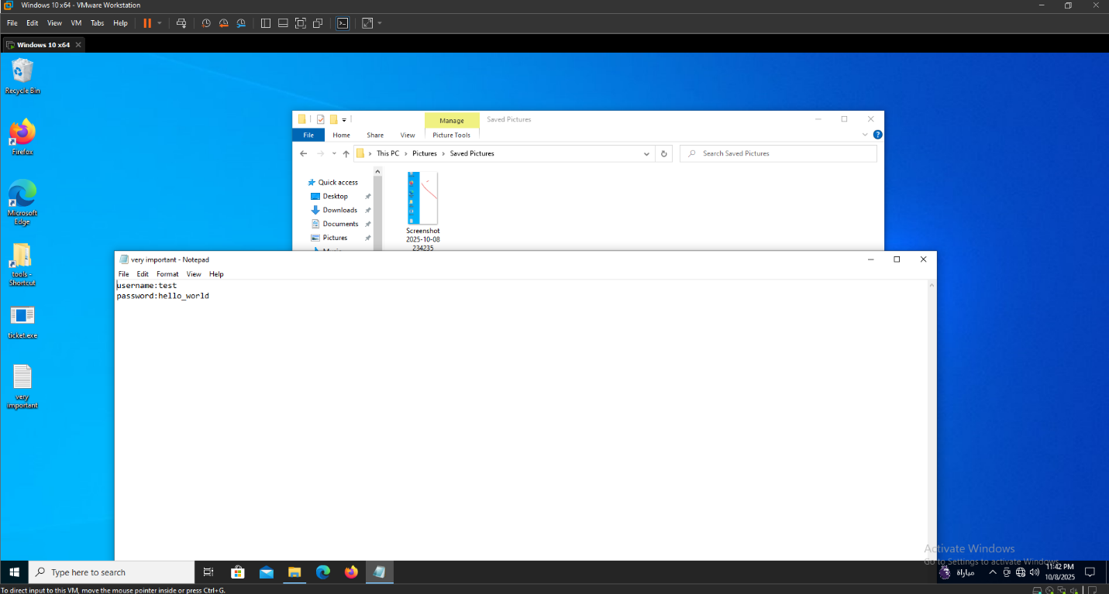
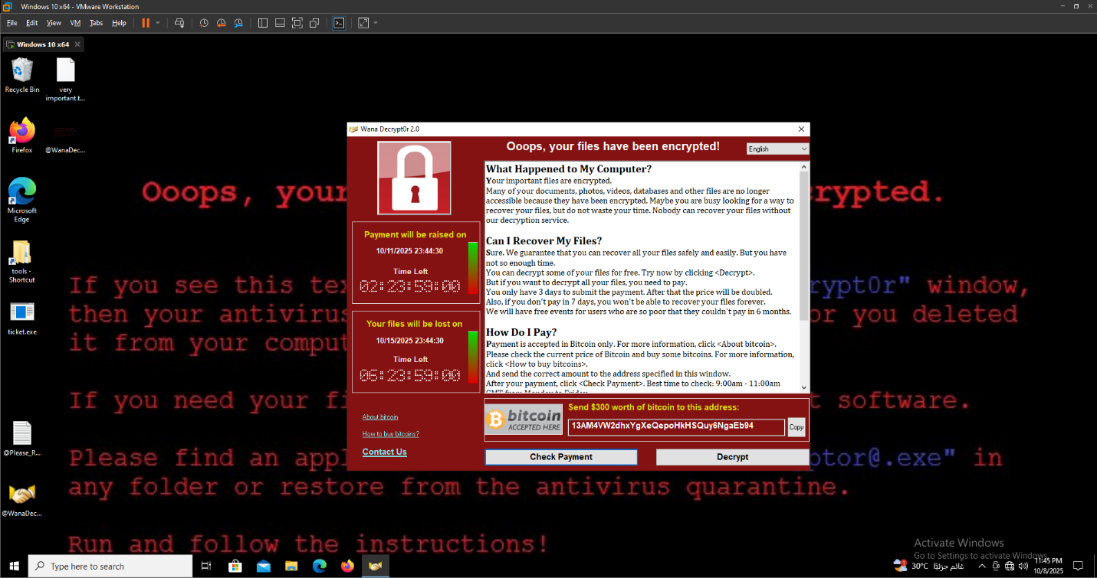

9. Disk & Memory Image Acquisition
Once images are captured, verify their integrity using the acquisition tool’s built-in verification/confirmation features and confirm the images are readable. Store the images securely for analysis (use encrypted or access-controlled storage). As noted in digital forensics best practices, a complete bitstream image is the standard “forensic duplicate” for later analysis.
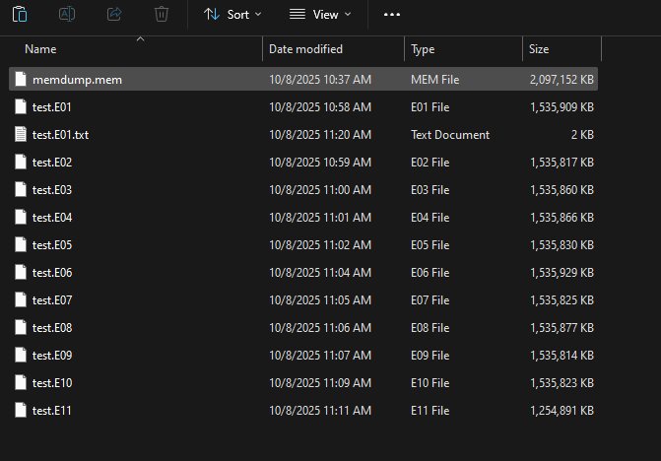

10. Forensic Analysis & Indicators of Compromise (IOCs)
Using the disk and memory images, analysis proceeded with Volatility (for RAM) and registry / file-viewing tools (for the disk image). Volatility was used to enumerate running processes, show process trees, and inspect loaded modules from memory. In the memory image we identified two notable items via pstree / pslist style output and process inspection:
- A process named @wannacrydecryptor present in memory and showing behavior consistent with a dropped/running payload (visible in the process list).
- A process named tasksche.exe shown running from a suspicious filesystem location (reported in the process tree and confirmed by memory-resident module information).
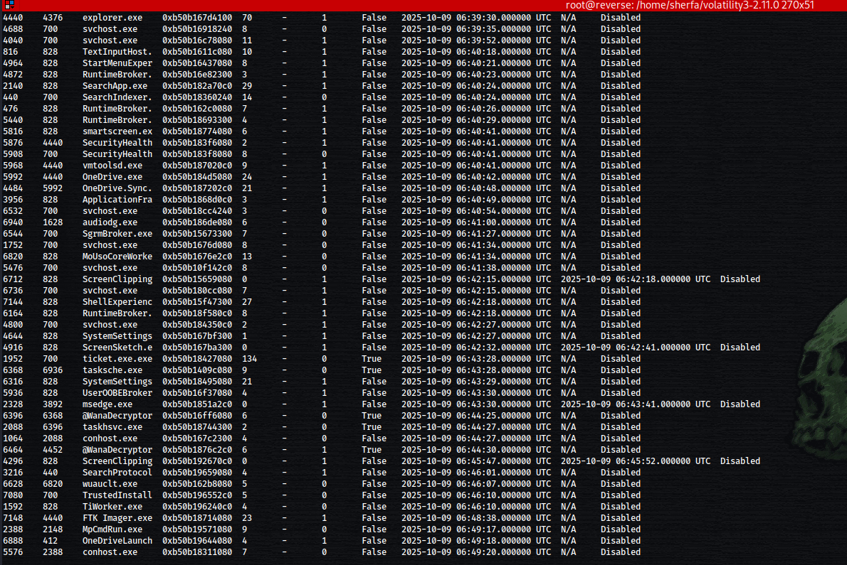
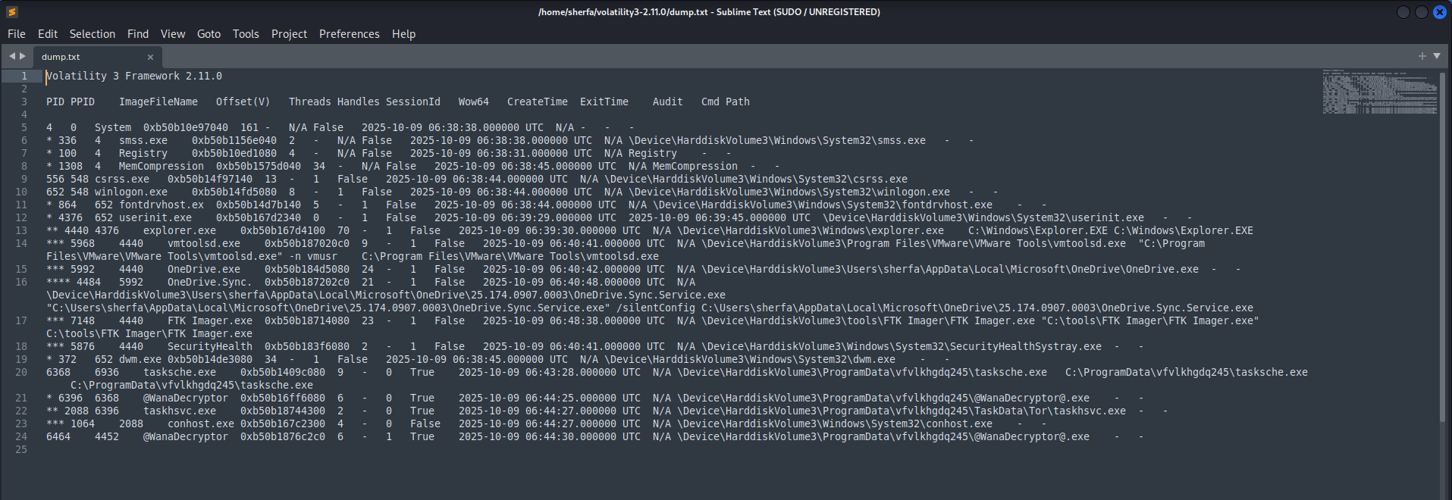
On the disk image, registry analysis revealed a persistence entry created to maintain execution across reboots. The specific Run key discovered was:
HKEY_LOCAL_MACHINE\SOFTWARE\WOW6432Node\WanaCrypt0
This Run key referenced the persistence executable (the same path/name observed in the memory analysis). In this controlled lab, the registry Run key plus the in-memory evidence of @wannacrydecryptor and tasksche.exe form the primary indicators of compromise (IOCs) for the simulated infection.
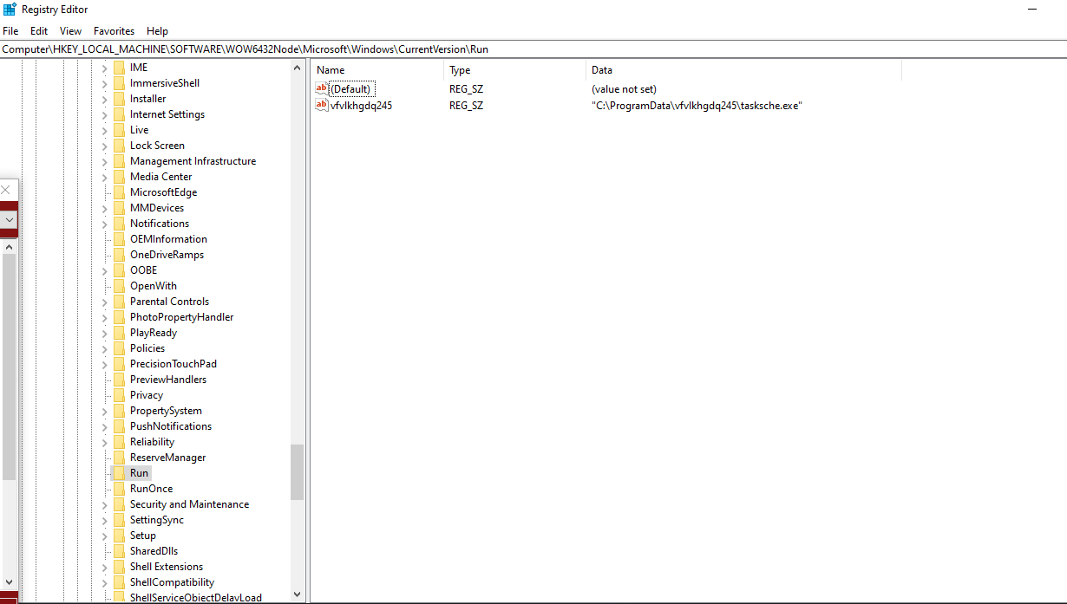
HKEY_LOCAL_MACHINE\SOFTWARE\WOW6432Node\Microsoft\Windows\CurrentVersion\Run

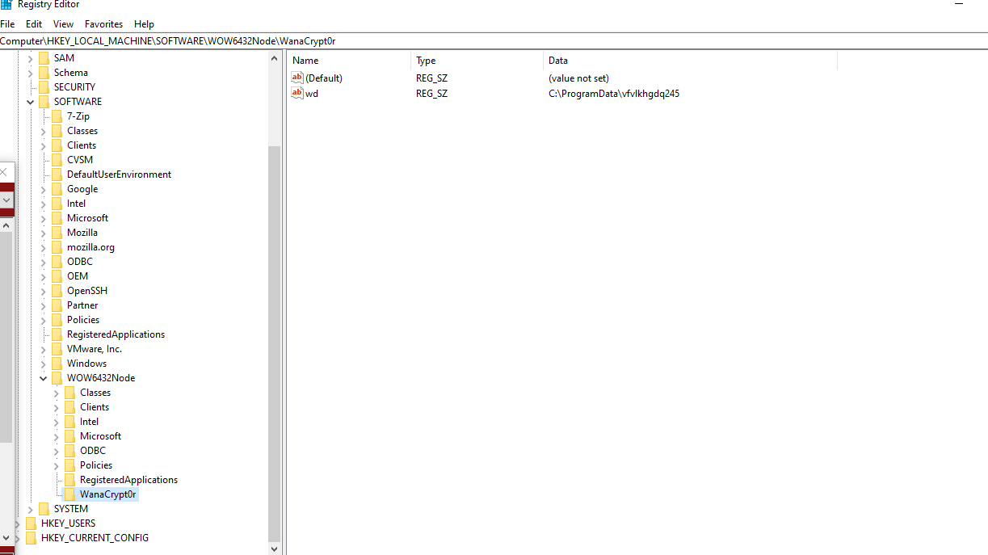

HKEY_LOCAL_MACHINE\SOFTWARE\WOW6432Node\WanaCrypt0 Run

11. MITRE ATT&CK Mapping

Stage | Technique ID | Technique Name | Description
Initial Access | T1566.001 | Phishing: Spearphishing Attachment | The phishing email (sent via GoPhish) contained a download link to ticket.exe, representing a malicious attachment or link lure.
Execution | T1204.002 | User Execution: Malicious File | The victim executed ticket.exe believing it was a raffle ticket; this initiated the simulated ransomware payload.
Persistence | T1547.001 | Registry Run Keys / Startup Folder | Registry key HKEY_LOCAL_MACHINE\SOFTWARE\WOW6432Node\WanaCrypt0 ensured the payload (tasksche.exe) ran on startup.
Defense Evasion | T1036.005 | Masquerading: Match Legitimate Name or Location | The payload used legitimate-sounding filenames like tasksche.exe to avoid suspicion.
Impact | T1486 | Data Encrypted for Impact | While the mock payload did not encrypt real files, it simulated the encryption process and displayed a ransom message, demonstrating this technique safely.
Command & Control | T1071.001 | Application Layer Protocol: Web Protocols | In a real-world WannaCry-style attack, communication to a command server would occur via HTTP/S; this behavior was conceptually discussed but not executed.

12. Cyber Kill Chain
Kill Chain Phase | What happened in the simulation | Artifacts / Evidence | Was it detected? If so how & when
Reconnaissance | Attacker (simulator) prepared the lure and target list (created email template and CSV of targets). | GoPhish templates, targets.csv, project notes. | Not detected – preparation phase.
Weaponization | Created the payload concept (ticket.exe mock) and phishing HTML body | ticket.py source, PyInstaller build artifacts, HTML template. | Not detected – payload preparation.
Delivery | Email sent via GoPhish MailHog; phishing email delivered to target inbox | MailHog captured mails, GoPhish “Sent” entries. | Not detected – email successfully delivered.
Exploitation | The victim clicked the link and executed ticket.exe on the test VM. This is where code ran. | Download logs, ticket.exe execution on VM, process entry in memory. | Detected here – Late Detection: Infection became visible only after execution (ransomware activity observed).
Installation | Registry Run key added to maintain persistence (HKLM\...\WanaCrypt0 referencing the payload). | Registry hive from disk image, Run key entry, file path referenced by key. | Detected later during forensic analysis (post-infection).
Command & Control (C2) | Simulated / Not executed. In a real WannaCry variant C2 or worming may exist; no external C2 activity was performed in the lab. | N/A (no network callbacks executed). | Not applicable.
Actions on Objectives | impact renamed demo files and displayed ransom-note UI (simulated data encryption). | demo_files with .encrypted names, ticket_log.txt, ransom-note popup screenshots. | Observed as visible system impact.

12.1 Detection Summary
- Detection occurred late, during the Exploitation phase, after the payload executed.
- Volatility analysis revealed malicious processes (@WannaCryDecryptor, tasksche.exe) running from suspicious paths.
- FTK Imager and registry examination showed a persistence entry at HKLM\SOFTWARE\WOW6432Node\WanaCrypt0.
- These findings confirm that the simulated ransomware successfully executed before detection, which reflects real-world challenges in early ransomware identification.

13. Incident Response and Post-Incident Activities
After identifying the infection indicators in memory and registry analysis, an incident response workflow was initiated to contain, analyze, and recover the affected system within the controlled lab environment.

13.1 Containment and Recovery Actions
Following the forensic findings, we took several steps to safely manage and restore the affected virtual machine:
- Root Cause Analysis:
The infection originated from the execution of the downloaded ticket.exe, which simulated the WannaCry behavior after a successful phishing email interaction. The root cause was confirmed to be user interaction with the phishing attachment, demonstrating the effectiveness of social engineering tactics.
- Isolation of Affected Systems:
The infected VM was immediately isolated from the lab network to prevent any possible propagation or external communication. No data exfiltration or cross-system infection occurred, as confirmed through network monitoring and memory analysis.
- System Recovery:
After isolation, we restored the affected VM using a clean backup image created before the simulation. This ensured the environment was returned to a stable state without residual infection. FTK Imager was used to verify the backup image before restoration.

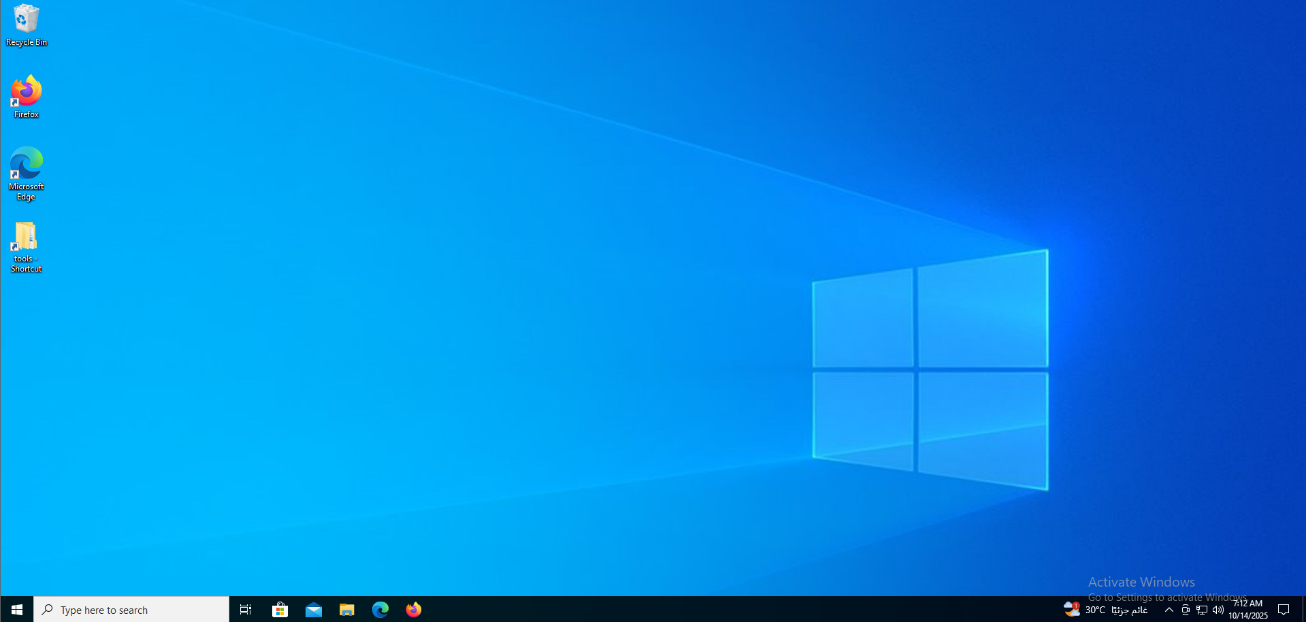

14. Recommendations & Mitigations
Based on the analysis of the phishing and ransomware simulation, several preventive and corrective security controls are recommended. These measures address the weaknesses that allowed the simulated infection to occur and strengthen defenses against similar real-world attacks.

14.1 User Awareness and Training
- Conduct regular phishing-awareness sessions to help users identify suspicious emails and attachments.
- Include periodic phishing simulations using safe frameworks like GoPhish to test employee readiness.
- Reinforce a “Think Before You Click” culture — encourage users to report unexpected links or downloads.
- Establish a clear incident-reporting channel (e.g., report@company.local) to quickly escalate suspicious messages.

14.2 Email Security Controls
- Implement SPF, DKIM, and DMARC to prevent domain spoofing and reduce phishing success rates.
- Deploy email filtering and sandboxing to analyze attachments and links before delivery.
- Block or quarantine executable attachments (.exe, .bat, .js) at the mail gateway.
- Use URL rewriting and scanning to inspect links embedded in emails.

14.3 Endpoint and System Hardening
- Enable Application Whitelisting to restrict execution to approved software only.
- Maintain regular patch management across all systems to reduce exploitability of vulnerabilities.
- Deploy Endpoint Detection & Response (EDR) or antivirus tools with behavioral analysis to detect and stop ransomware-like activity.
- Enforce least-privilege principles for user accounts to limit damage if compromise occurs.

14.4 Backup and Recovery Practices
- Maintain regular, automated backups stored offline or in immutable cloud storage.
- Periodically test backup restorations to confirm data integrity and recovery speed.
- Keep multiple backup generations to ensure recovery even if recent data becomes compromised.
- Document backup schedules and recovery points within organizational policies.

14.5 Network and Monitoring Enhancements
- Segment critical systems and servers from user networks using VLANs or subnets.
- Implement Network Intrusion Detection/Prevention Systems (NIDS/NIPS) to detect suspicious traffic.
- Log all authentication and network events centrally in a SIEM for correlation and alerting.
- Regularly review logs for anomalies and failed login attempts.

14.6 Policy and Governance
- Establish a formal Incident Response Plan (IRP) defining roles, escalation paths, and communication protocols.
- Maintain a forensic readiness plan to ensure evidence (memory, disk, logs) can be acquired safely in future incidents.
- Update security policies and standard operating procedures (SOPs) based on lessons learned from this project.
- Conduct annual audits of both technical and procedural controls to ensure compliance and effectiveness.

15. Project Summary & Conclusion
This project successfully simulated a full phishing-to-ransomware attack chain in a controlled laboratory environment to demonstrate the real-world lifecycle of a cyber incident — from initial compromise to detection, analysis, and recovery.
The simulation began with a phishing campaign using GoPhish and MailHog, where a crafted email imitating a “Fawryz giveaway” lured the victim into downloading a malicious executable named ticket.exe. Once executed, the payload simulated ransomware behavior similar to WannaCry, encrypting files and creating persistence via registry modifications under
HKEY_LOCAL_MACHINE\SOFTWARE\WOW6432Node\WanaCrypt0.
Following infection, FTK Imager was used to capture disk and memory images, which were then analyzed using Volatility 3 to identify malicious processes such as @WannaCryDecryptor and tasksche.exe. These artifacts, along with the persistence registry key, served as clear Indicators of Compromise (IOCs).
A Chain of Custody was maintained throughout evidence acquisition to preserve forensic integrity.
In the recovery phase, the affected virtual machine was isolated, and data was successfully restored using a clean backup image, completing the containment and recovery steps.
Finally, the MITRE ATT&CK framework was used to map adversary behavior and identify key tactics such as initial access, execution, persistence, and impact.
Based on these findings, a set of recommendations and mitigations was developed to strengthen security posture — including user awareness, email filtering, endpoint protection, backup management, and formal incident response planning.
In conclusion, the project demonstrated the complete cybersecurity incident lifecycle:
- Attack Simulation (Phishing + Malware Execution)
- Forensic Investigation (Evidence Collection & Analysis)
- Incident Response (Containment, Eradication, Recovery)
- Post-Incident Review (Lessons Learned & Recommendations)
This end-to-end approach reflects real-world practices used by cybersecurity professionals to detect, analyze, and respond to modern threats. It highlights the importance of combining technical defenses, user training, and procedural discipline to maintain resilience against evolving cyberattacks.

